**Initial findings Sales Analysis**

1. Correlation between product family based on Seats:

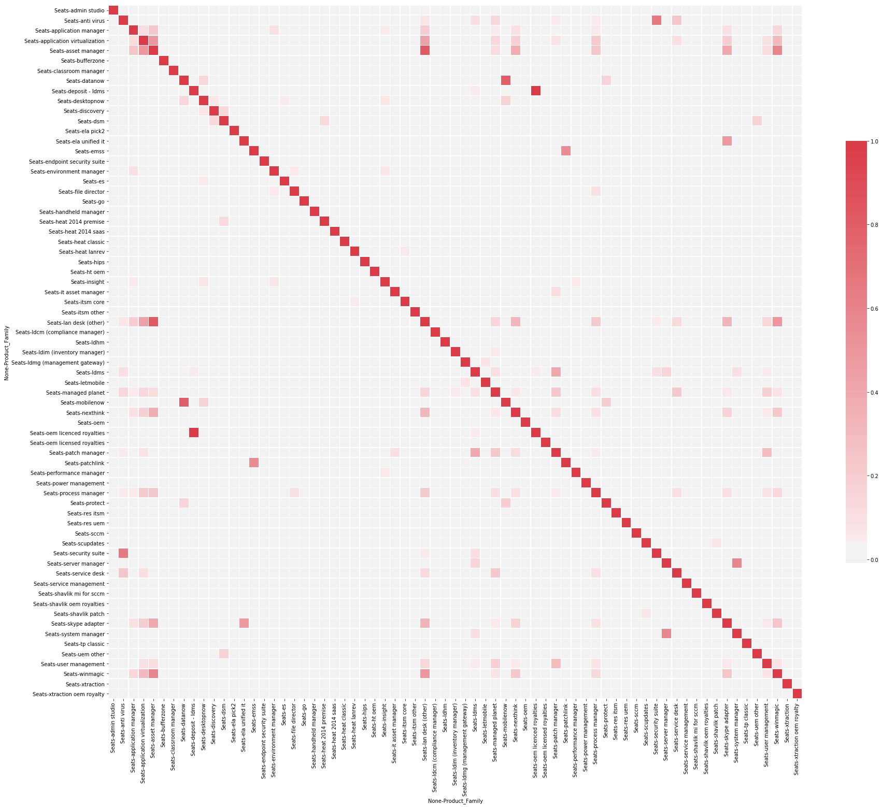

Observation: Some products are correlated, implying they are frequently bought together. Hence whenever a customer buys a product, other related products can be recommended.

Below is a list of products that crosses a threshold of 0.2 correlation.

(('Seats', 'anti virus'), ('Seats', 'security suite'), 0.6594956607051231)

(('Seats', 'anti virus'), ('Seats', 'service desk'), 0.2409536908370047)

(('Seats', 'application manager'), ('Seats', 'asset manager'), 0.23643966777265377)

(('Seats', 'application virtualization'), ('Seats', 'asset manager'), 0.4927808932844442)

(('Seats', 'application virtualization'), ('Seats', 'lan desk (other)'), 0.43239432612161094)

(('Seats', 'application virtualization'), ('Seats', 'process manager'), 0.21786629752329206)

(('Seats', 'application virtualization'), ('Seats', 'skype adapter'), 0.2015163172083596)

(('Seats', 'application virtualization'), ('Seats', 'winmagic'), 0.29873409971937465)

(('Seats', 'asset manager'), ('Seats', 'lan desk (other)'), 0.8238864246717009)

(('Seats', 'asset manager'), ('Seats', 'nexthink'), 0.37121881712013804)

(('Seats', 'asset manager'), ('Seats', 'process manager'), 0.23006236436682223)

(('Seats', 'asset manager'), ('Seats', 'skype adapter'), 0.3992551935171325)

(('Seats', 'asset manager'), ('Seats', 'winmagic'), 0.5917993058837165)

(('Seats', 'datanow'), ('Seats', 'mobilenow'), 0.8028014085760271)

(('Seats', 'deposit - ldms'), ('Seats', 'oem licenced royalties'), 0.9964962449675884)

(('Seats', 'ela unified it'), ('Seats', 'skype adapter'), 0.4767649053266922)

(('Seats', 'emss'), ('Seats', 'patchlink'), 0.5526930889958099)

(('Seats', 'lan desk (other)'), ('Seats', 'nexthink'), 0.314345511008342)

(('Seats', 'lan desk (other)'), ('Seats', 'process manager'), 0.21505783621878485)

(('Seats', 'lan desk (other)'), ('Seats', 'skype adapter'), 0.33715368379864263)

(('Seats', 'lan desk (other)'), ('Seats', 'winmagic'), 0.49863073044933887)

(('Seats', 'ldms'), ('Seats', 'patch manager'), 0.3937131991343882)

(('Seats', 'managed planet'), ('Seats', 'patch manager'), 0.2217835875754549)

(('Seats', 'managed planet'), ('Seats', 'service desk'), 0.22496743516970108)

(('Seats', 'nexthink'), ('Seats', 'winmagic'), 0.22522953875382537)

(('Seats', 'patch manager'), ('Seats', 'user management'), 0.2953766522193118)

(('Seats', 'server manager'), ('Seats', 'system manager'), 0.581224768781254)

(('Seats', 'skype adapter'), ('Seats', 'winmagic'), 0.2422366882600851)

1. Correlation between product family based on Seats modified (Seats > 0 => Seats_mod = 1, Seats = 0 => Seats_mod = 0, Seats < 0 => Seats_mod = -1).

The idea is to nullify the effect of volumes as large organizations would always buy more seats, and hence skewing our analysis. Although this method has its shortcomings, but will figure it out later.

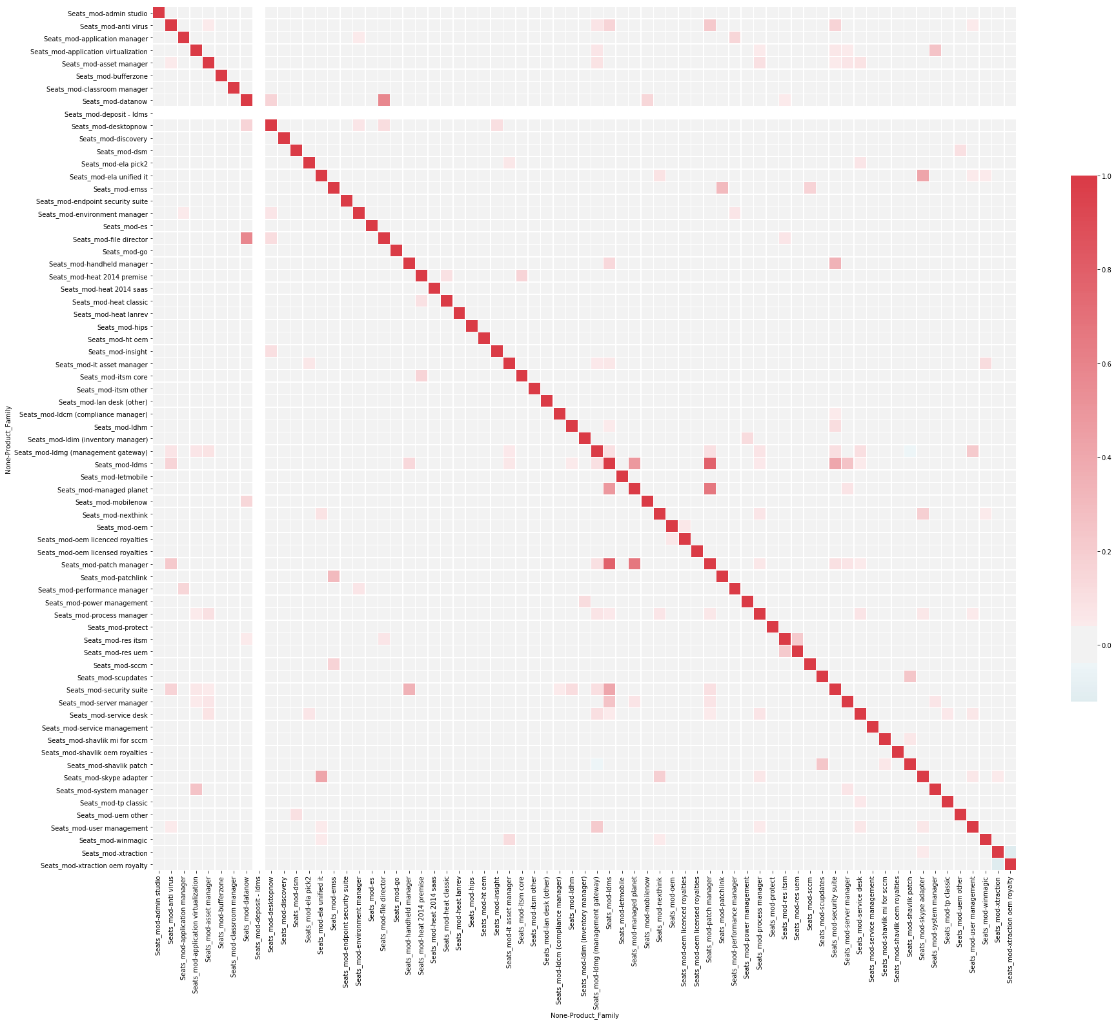

The blank column and row for “deposit-ldms” is because its Seats_mod = 0 and hence no variation, Thus the correlation is infinity.

Below is the list of correlated products:

(('Seats_mod', 'anti virus'), ('Seats_mod', 'patch manager'), 0.2208095262821003)

(('Seats_mod', 'application virtualization'), ('Seats_mod', 'system manager'), 0.2558759201958388)

(('Seats_mod', 'datanow'), ('Seats_mod', 'file director'), 0.5839282189439385)

(('Seats_mod', 'ela unified it'), ('Seats_mod', 'skype adapter'), 0.4172893000036134)

(('Seats_mod', 'emss'), ('Seats_mod', 'patchlink'), 0.30028785577295247)

(('Seats_mod', 'handheld manager'), ('Seats_mod', 'security suite'), 0.35055513254507326)

(('Seats_mod', 'ldmg (management gateway)'), ('Seats_mod', 'user management'), 0.21335104661652354)

(('Seats_mod', 'ldms'), ('Seats_mod', 'managed planet'), 0.4845010783642546)

(('Seats_mod', 'ldms'), ('Seats_mod', 'patch manager'), 0.7863541238539452)

(('Seats_mod', 'ldms'), ('Seats_mod', 'security suite'), 0.4100300598694862)

(('Seats_mod', 'ldms'), ('Seats_mod', 'server manager'), 0.2535776289847414)

(('Seats_mod', 'managed planet'), ('Seats_mod', 'patch manager'), 0.6695394089524608)

(('Seats_mod', 'res itsm'), ('Seats_mod', 'res uem'), 0.22066716183218427)

(('Seats_mod', 'scupdates'), ('Seats_mod', 'shavlik patch'), 0.24154796144096025)

An example of wrong data:

A further deep dive showed how the volumes of Seats could skew the analysis:

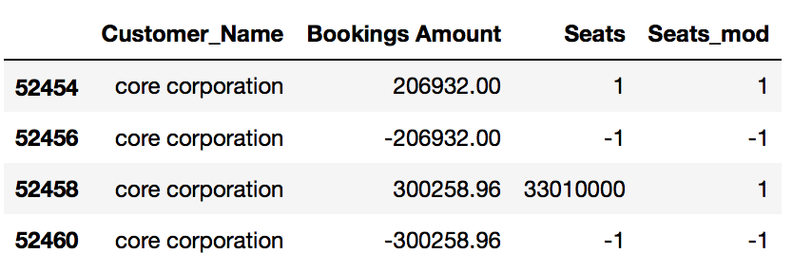

As evident something is wrong with the data entry, Bookings_Amount for 458 and 460 are complementary but Seats are different.